CITIZEN’S SUMMARY
of the 2019 Annual Implementation Report for
Interreg V-A Programme Romania – Bulgaria

Progress:
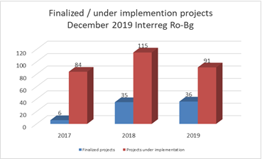
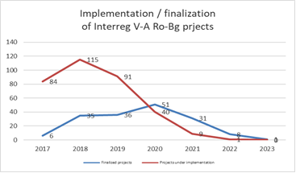
- 45% of the projects finalized the implementation;
- Priority axis 4 and 5 almost closed;
- Absorption rate: 63,274,436 euro, 29.33%.

Results
Projects have been implemented and important results are achieved. Find out the main project’s outputs at: https://interregrobg.eu/en/projects/outputs.html under the following main fields of interest:

Tourism:
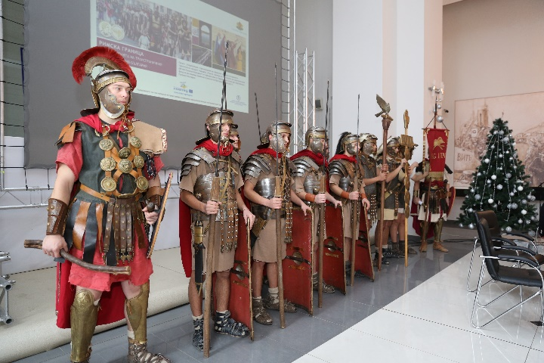
34 integrated touristic products /services have been created, including a total number of 142 different touristic routes (bicycle routes, hiking routes, kayaking on the Danube routes, routes for cultural sites, for historical sites in the area, one on line guide for religious tourism in the cross border area, etc.), studies and strategies for development of tourism, mobile applications and websites.

Environment:
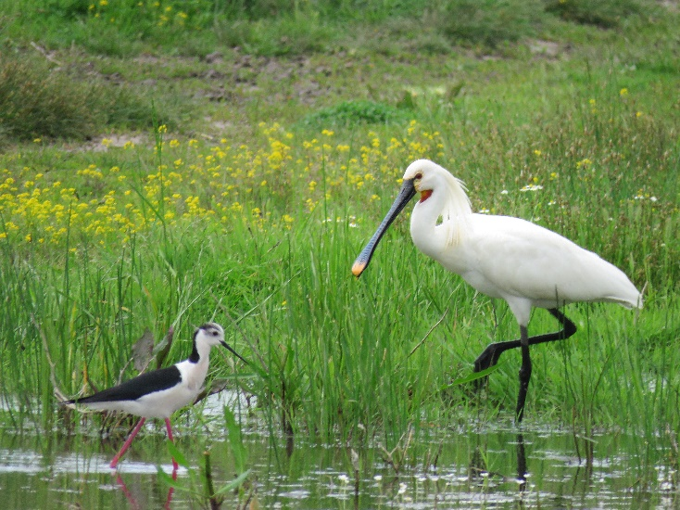
27,059 hectares were supported to attain a better conservation status by developing joint management plans for 4 NATURA 2000 sites (Suhaia and Confluenta Olt-Dunare in Romania and Ostrov Vardim and Ribarnitzi Hadji Dimitrovo in Bulgaria) and by
cataloguing and studying 7 other NATURA 2000 sites and protected areas from Vidin to Oriahovo („Zlatiyata“ Bg0002009; “Island Next To Gorni Tsibar” Bg0002008; “Orsoya Fishponds” - Bg0002006; Island Ibisha” - Bg0002007; „Tsibar Swamp“ - Bg0002104; “Golya Island“ - Bg0002067; „Orsoya“ - Bg 0000182; „Kozloduy“ - Bg000527; „Tsibar“ - Bg0000199; „Island Steppe Vadin“ - Bg0000528; „Ostrov“ - Bg0000334; „Ogosta River“ - Bg0000614; „Archar“ - Bg0000497; “Kozloduy Islands“ - Bg0000533; “Tbliznatsi Islands” - Bg0000532; “Kutovo Island” - Bg0000552) and Mehedinti (“Iron Gates“ - Rosci0206; „Blahnita“ - Rospa0011; „Starmina Forest“ - Rosci0173; Area Along The Danube To Garla Mare – Maglavit - Rosci0299; „Mehedinti Plateau“ - Rosci0198).
In addition, a portal for reporting any incident can be accessed at https://incolab.gnm.ro, and an application for mobile phones ("Incolab") is available on Google Play.
Risk management:
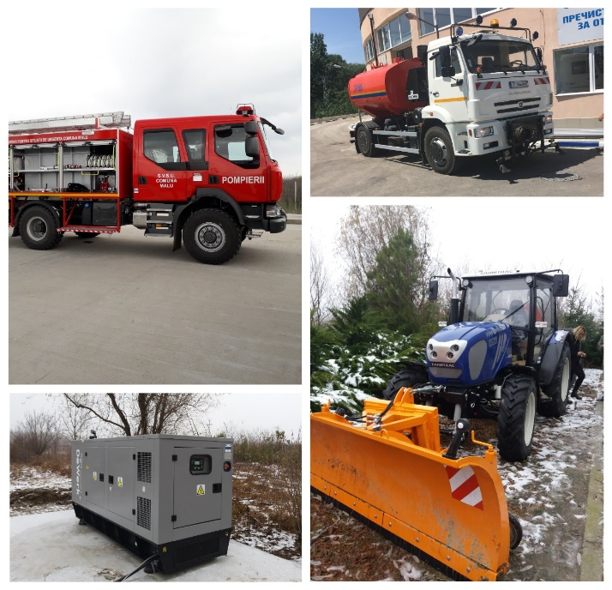
Increased cooperation in risk management in Byala, Bulgaria and Gradinari and Malu is now ensured by endowing the responsible authorities with specific equipment (2 Backhoes, 2 motor pumps, 3 electric power generators, tractor with trailer and snow blade, water and foam truck, portable radio stations, etc.).
Studies on Impact Indicators for Large Scale Infrastructures and defining the methodology for risk management within the cross-border area were drafted.
More relevant results still to come in 2020.

Employment / Labour Market:
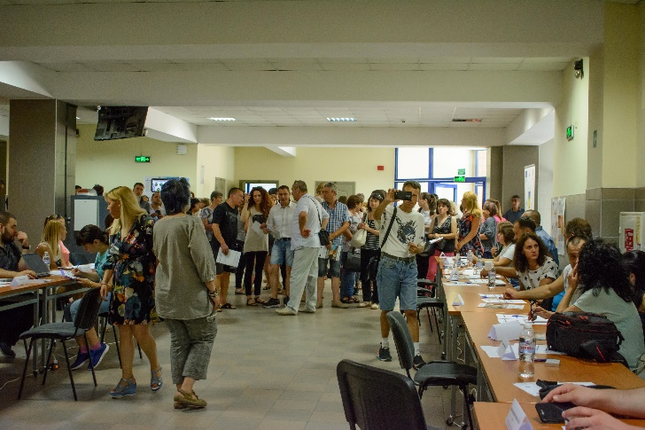
162 initiatives to activate workforce mobility in the cross-border area were developed. They include surveys / studies / strategies in different field of interest (vocational schools, bio agriculture, students, in tourism, social assistance for persons with disabilities, for minorities, etc.) for the cross- border labour market, trainings (18.474 participants), a guide for commuters, a trilingual RO-BG-EN dictionary of specific terms in the construction field, websites with available jobs in the cross-border area and other interactive information regarding the labour market, etc.
One cross-border agency for work mobility with offices and trained staff in Ruse Bulgaria and Slatina, Romania, is offering services for work mobility to both, employees and employers at its headquarter and also online.
Public administration:
62 cross border mechanisms have been developed to enhance cooperation capacity: partnerships for cooperation in the field of renewable energy, territorial development, educational policies in public schools; tourism and eco-tourism; development of webpages including information for the public. Public authorities have been endowed with specific equipment improving their public services for citizens.
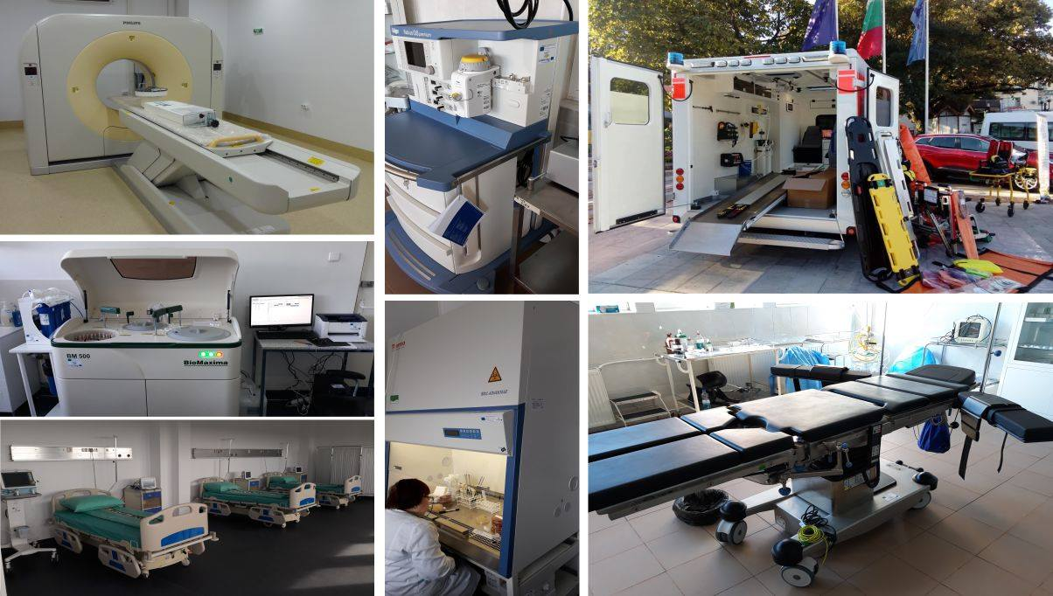

Transport:
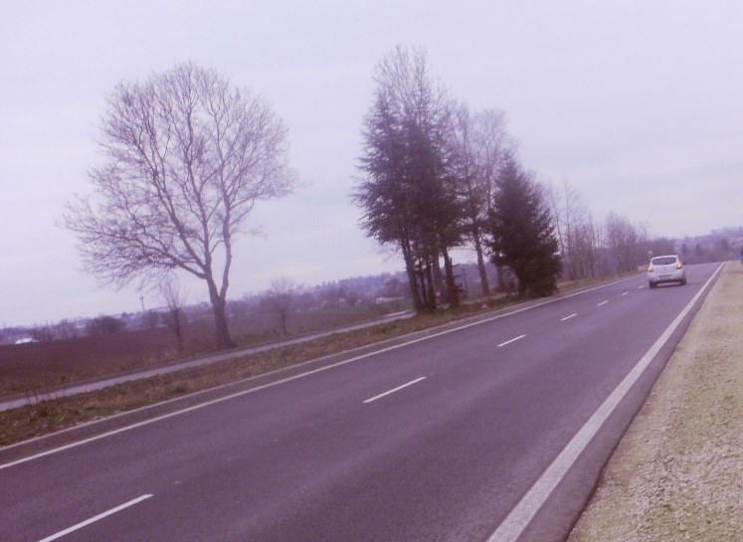
30.61 km of roads were already modernized and for 175.70 km of roads the public procurement procedures were started.

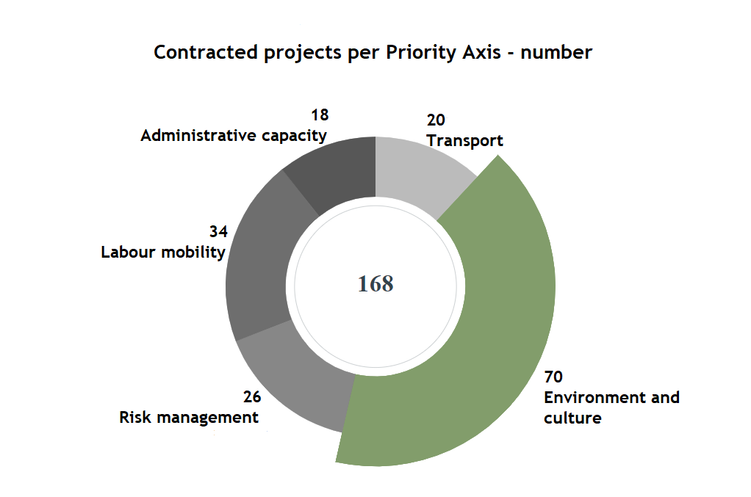
Performance in contracting and implementing operations
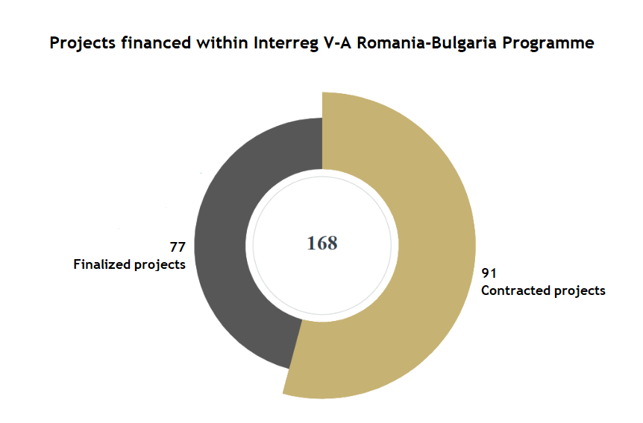

Performance in financing
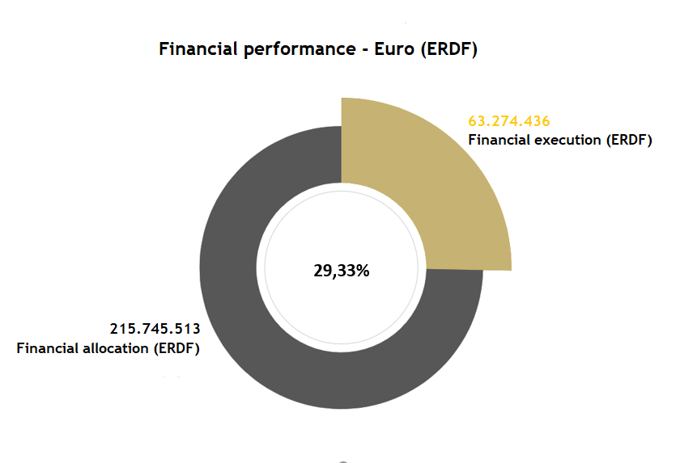
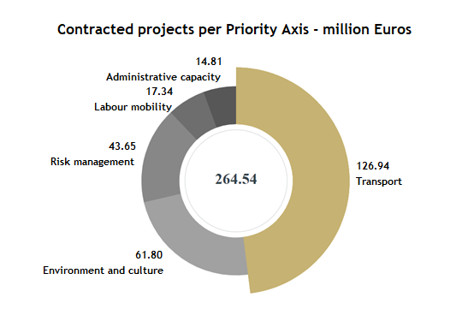

Keep an eye on us!

https://www.facebook.com/RomaniaBulgariaCbcProgramme?fref=ts
https://twitter.com/ROBGProgramme
https://www.youtube.com/channel/UCtgRgCcdOK5D2ZsBJrMPXew/videos
https://www.instagram.com/interregrobg/

